**The Moderating Role of Employees’ Job Satisfaction on the relationship between Employees’ Presenteeism and Their Subjective Happiness**

Lee Ang Ren

B1900594

PSY300: Undergraduate Thesis

Supervisor: Dr. Victor Goh Weng Yew

Co-Marker: Dr. Fam Jia Yuin

Department of Psychology

Faculty of Behavioural Sciences, Education & Languages

HELP University

Thesis submitted on March 17th in the year of 2023 in partial fulfillment for the Degree of Bachelor of Psychology

Word Count: _7380_words

**HELP University Department of Psychology Declaration**

I declare that this thesis is my original work; and to the best of my knowledge, it does not contain any materials previously published or written by another person except where sources are properly acknowledged in the text; and that it has not been submitted in part or in whole to fulfil the requirements of any other subject or course or for a degree or diploma or certificate in any university. In making this declaration, I hereby understand and acknowledge any breaches of the declaration constitute academic misconduct which may lead to my exclusion and / or expulsion from the programme and / or degree.



Signature of candidate: …………………………………… Date: …17th March 2023……...

Name of candidate: ………Lee Ang Ren……………

**Abstract**

The current study aimed to examine whether job satisfaction would moderate the relationship between presenteeism and subjective happiness. The current study has implemented a non-experimental correlational design. Seventy-four full-time workers, aged between 18 – 60, were recruited for the current study. The workers were asked to complete the Standford Presenteeism Scale, Subjective Happiness Scale, and Job Satisfaction Survey. The results of the current study showed that there was no significant correlation between the relationship between presenteeism and subjective happiness. Hence, the hypothesis proposed that job satisfaction would moderate and strengthen the negative relationship between presenteeism and subjective happiness was not supported. The study concluded that presenteeism can be an important factor to consider when studying subjective happiness.

*Keywords*: presenteeism, job satisfaction, subjective happiness

Word Count: _116_ words

**The moderating role of employees’ job satisfaction on the relationship between employees’ presenteeism and their subjective happiness**

"Terrible work-life balance", or "I am unhappy because of my job", are some of the common complaints of a worker about their jobs (Morgan, 2023). In some cases, the amount of job stresses an individual is facing can even correspond to a weaker and ill-often body (Ilies et al., 2010). All of these were directed towards how far an individual can go to achieve the certain amount of productivity required, or in short, to achieve the required amount of key performance indicators (KPI). In this case, productivity was both beneficial for the company and the employees themselves, whereby having a higher KPI may benefit employees from an increment of income et cetera, thus pushing the employees to maintain or strive for greater productivity. However, such an issue had impacted many employees to the point that workers were forced to show up at work despite being ill to accomplish their work (Werapitiya et al., 2015). In this case, such a phenomenon may cause individuals to have a poor work-life balance, hence the complaints of unhappiness towards their lifestyle.

Towards the field of positive organizational psychology, discussions directed at employees' productivity were often a well-studied area and focused on by many I/O psychologists. The factors behind what impacts or improves the employees' productivity are often studied to identify, recognize, and potentially make predictions for employees to maintain their productivity (Kuykendall & Tay, 2015; Misra & Srivastava, 2022). That is, though many factors were discussed and tested, one potential factor stood out the most as productivity was most often majorly influenced by it, with such factor being the employees' subjective happiness (Bellet et al., 2019; Bryson et al., 2017; Kuykendall & Tay, 2015). For this, it can be seen from more employees' complaints about their feeling of unhappiness due to their stressful yet imbalanced lifestyle (Hasan et al., 2020). Hence, the current research was important to study how employees' general happiness may come into place with their general productivity.

**Subjective-Happiness**

Subjective happiness, more broadly referred to as subjective well-being, can be defined as the positive emotion of how one may perceive their life (Lyubomirsky & Lepper, 1999). For this, subjective happiness was an important factor within an individual when it comes to positive organizational psychology, such that an individual with lower subjective happiness may potentially suffer from increased workplace stress, lowered motivation, loss of their sense of commitment, lowered job satisfaction, or even causing potential physical illnesses to their very own body (Kun & Gadanecz, 2019; Kuykendall & Tay, 2015). From the perspective of self-determination theory, subjective happiness may allow individuals to feel autonomously motivated and hence perform better at work with greater productivity (Manganelli et al., 2018). For instance, it was stated that employees would be more proactive and display higher concentration, persistence, and effort when they are autonomously motivated by their higher sense of subjective happiness (Manganelli et al., 2018).

Interestingly, with various potential influences that may impact an employee's subjective happiness, more focus was going on job satisfaction, or presenteeism (Cooper & Lu, 2016; Karanika-Murray & Biron, 2019; Magalhães et al., 2022). A past study had shown that higher subjective happiness may lead to better physical health of an individual, by which having a happy person with greater self-determination would also moderate positively towards greater physical health (Marcinko, 2015). That being said, it is possible that a person with a lower sense of self-determination and subjective happiness may cause the individual to suffer from weaker physical health (Marcinko, 2015). As some employees tend to show up to work in order to achieve their required productivity, some of them may attempt to show up to work despite being sick or having terrible health symptoms (Min & Hong, 2022). Such a phenomenon can be described as the act of presenteeism.

**Presenteeism**

The discussion of the topic of presenteeism has only just recently come to the researchers' interest and is still considered a new topic of discussion. The term presenteeism itself is still considered new and is defined as the act of being physically present at work while being sick in order to maintain work performance despite having a reduced amount of productivity or a lesser work quality (Koopman et al., 2002; Werapitiya et al., 2015). As suggested by self-determination theory, it is notable that people who engage in presenteeism behaviour with controlled motivation may experience an outcome that may negatively affect their subjective happiness from their loss of productivity or frequent leaves from work (Gillet et al., 2021). However, people with an autonomous motivation that engages in presenteeism may instead positively impact their subjective happiness, which helps one in self-regulation and lessens the negative outcomes of presenteeism (Gillet et al., 2021; Karanika-Murray & Biron, 2019). From that, it was clear that individuals with autonomous motivation were intrinsically motivated to achieve their productivity despite engaging in presenteeism as they may feel as if they were more respected (Fisher, 1978). In contrast, people with controlled motivation would perceive that they have no control over themselves, which causes a deterioration in their sense of autonomy and results in lower intrinsic motivation (Fisher, 1978). With that, the link between presenteeism and subjective happiness was able to establish both positive and negative outcomes (Gillet et al., 2021; Karanika-Murray & Biron, 2019).

Past study has also suggested that individuals who perceived their rewards to be expected tend to result in lower intrinsic motivation (Lepper et al., 1973). As an example, an individual who perceives that themselves only working hard and achieving their target productivity because their job pays well even though they do not enjoy anything about their work, in which showing the form of continuance commitment where they felt that they needed the job despite being unhappy within the organization (Ma et al., 2018; Riggio, 2017). It is possible that they felt no control over their own decision and that their motivation was only from the expected monetary rewards from the organization, which had potentially resulted in a lower intrinsic motivation, hence lower subjective happiness (Fisher, 1978; Lepper et al., 1973). Following that, job demand may come into place as well where it was previously mentioned that employees would show up to work despite being sick in look to achieve their productivity goals given by their superiors (Demerouti et al., 2009).

In this case, job demand was an underlying factor that lies between presenteeism and subjective happiness (Demerouti et al., 2009). This is because job demand was found to be a common factor relating to presenteeism (Gillet et al., 2020; Min & Hong, 2022; Mokhtar et al., 2019) According to Min and Hong (2022), workers with a higher job demand are more likely to choose presenteeism. This is because employees may tend to choose presenteeism to achieve a certain productivity goal, by which they tend to perceive less control or decision authority towards the goal which may result in occasional burnout (Demerouti et al., 2009; Min & Hong, 2022). Additionally, Min and Hong (2022) also emphasize that the interaction between job demand and subjective happiness was buffered across the general autonomy an individual perceived towards their job. That said, when an individual perceives lower autonomy towards their job, it may potentially result in lower subjective happiness (Min & Hong, 2022). Using SDT as the potential explanation, it is possible that employees who experience a lower sense of autonomy due to their high job demands may choose presenteeism to fulfill their given demands, which may cause them to experience burnout more often, and result in lower subjective happiness (Min & Hong, 2022).

However, it is also possible that job demand may produce greater subjective happiness by accomplishing their productivity goals, as mentioned that if they are autonomously motivated, the needs for competence were possibly fulfilled and resulting in greater subjective happiness (Gillet et al., 2021; Karanika-Murray & Biron, 2019). Besides, respect and support from superiors by accomplishing the given job demands may also fulfill their sense of relatedness, as mentioned individuals with autonomous motivation may feel intrinsically motivated to accomplish their tasks when they feel respected by their superiors, which helps them to potentially develop greater subjective happiness (Fisher, 1978). Therefore, job demands were able to explain the underlying relationship between presenteeism and subjective happiness, yet the direction of the relationship between presenteeism and subjective happiness was unclear as two different directions can be seen from the relationship between the two variables (Fisher, 1978; Min & Hong, 2022).

**Job satisfaction**

Additionally, an outcome of an individual's job demand may be their own satisfaction with their job. Past study has suggested that job demands may play a role in negatively impacting job satisfaction (Anand & Cato, 2021). That being said, it is possible that job satisfaction may be a potential insight that may play a role in the relationship between presenteeism and subjective happiness. This is because past study has mentioned that job satisfaction may potentially be negatively influenced by the individual's burnout, which was a common symptom of active presenteeism that is caused by higher job demands (Abadi et al., 2021; Demerouti et al., 2009). With that in mind, employees may feel unsatisfied with their job due to the heavy job demands that force them to choose presenteeism, which may result in having lower subjective happiness of the individual (Abadi et al., 2021). Dwyer and Ganster (1991) also found that when employees perceived that they have no control over the demands given to them, the employees may feel less satisfied with their job, which causes them to experience lower subjective happiness. Such findings have aligned with self-determination theory where employees with a lower sense of autonomy due to their perceiving of controlled motivation may impact their overall satisfaction towards their job, in which individuals may feel that they have no control but to engage in presenteeism, and potentially leads to lower subjective happiness as well (Dwyer & Ganster, 1991).

For this, job satisfaction refers to one's emotional-affective response towards different aspects of their job (Spector, 1985). A study done by Côté et al. (2021) has stated that individuals with presenteeism often perceive their working environment as unsatisfied or stressful, which shows a connection between presenteeism and job satisfaction (Abdi et al., 2021). Moreover, job satisfaction also forms a connection with subjective happiness (Cannas et al., 2019). That is, an individual with lower job satisfaction would establish lower subjective happiness and vice versa (Calaguas, 2017). From the perspective of self-determination theory, employees may experience lower subjective happiness when they have a lower satisfaction towards their job, where some factors of lower job satisfaction may be from their working environment, or their general productivity. As an example, employees may perceive a lower self-competence from their slower progress in a competitive working environment, especially with a given job demand, lower relatedness due to having a less friendly working environment, or lower autonomy from the flexibility of their job (Ma et al., 2018; Ryan & Deci, 2000). By putting all three variables together, employees who tend to engage in presenteeism may feel less autonomy such that they have no choice in look to achieve their target productivity, along with lower job satisfaction from experiencing lower competence and relatedness from their job demands or environment, individuals may result in lower subjective happiness as well (Ryan & Deci, 2000).

From there, since both presenteeism and subjective happiness result in two different directions of the outcome, it is possible that the relationship between the two variables would be moderated with the addition of job satisfaction. For example, if an employee with high presenteeism experiences lower competence and autonomy, as well as employees who also experience lower job satisfaction, it may lead to the outcome of lower subjective happiness, however, this is only an assumption. With that, the current study seeks to find out if job satisfaction could be a potential moderator within the relationship between presenteeism and subjective happiness.

**Research Gap and Implications**

As presenteeism is still a relatively new topic to be discussed, most studies only focus on work performance with presenteeism, but the idea of employees' subjective happiness is under-researched (Cooper & Lu, 2016; Karanika-Murray & Biron, 2019). Besides, it would be interesting to see if job satisfaction is able to moderate the direct relationship between presenteeism and subjective happiness, considering that presenteeism requires an individual to be present at work along with sickness or terrible health. It is possible that if an individual is satisfied with their jobs, the forced presence in their workplace will not be as detrimental to their subjective happiness, since the job is also a source of satisfaction to them (Chia & Chu, 2016; Gillet et al., 2021; Karanika-Murray & Biron, 2019). Other than that, as two different directions were found in the relationship between presenteeism and subjective happiness from past studies (Fisher, 1978; Gillet et al., 2021; Min & Hong, 2022), it is unclear whether presenteeism may serve to improve or worsen an individual's subjective happiness. Hence, the inclusion of job satisfaction may potentially reveal a clearer direction of the relationship between the two variables.

As the current study aims to find out whether job satisfaction can be a moderating factor between presenteeism and subjective happiness, job satisfaction will be employed to see whether it may potentially influence the relationship between the two factors. The current study will attempt to answer the research question: "Will employees' job satisfaction moderate the relationship between their presenteeism and subjective happiness?" The current study also hypothesizes that: "Job satisfaction will moderate the relationship between presenteeism and subjective happiness, with higher levels of job satisfaction strengthening the negative relationship between presenteeism and subjective happiness". For example, assuming that an employee with high presenteeism experiences lower levels of competence and autonomy, all while experiencing lower job satisfaction, it may lead to the employee having lower subjective happiness, which is interesting to test whether such an assumption may be true. That said, if such an assumption is true, it may help in developing techniques to effectively manage the negative effects of presenteeism within the employees of a company in the hope to achieve greater work productivity and better subjective happiness of an employee. As for the theoretical implications, the findings of the current study may provide some further insights into expanding the research area of the current research topic, which can be helpful for future studies of the current research area.

**Methods**

**Design**

The current study was a non-experimental correlational design, in which there were one predictor variable, one outcome variable, and one moderator variable. The predictor variable for the study was Employees’ presenteeism, followed by Employees’ subjective happiness as the outcome variable, and Employees’ job satisfaction as the moderator variable. Employees’ presenteeism was operationally defined as the total score on the context-modified SPS-6 scale, with a higher total score will indicate a higher level of presenteeism (Koopman et al., 2002). Next, Employees’ subjective happiness was operationally defined by the average score on the Subjective Happiness Scale, with a higher average score will indicate greater subjective happiness (Lyubomirsky & Lepper, 1999). Finally, Employees’ job satisfaction was measured with the total score on the Job Satisfaction Survey, whereby a higher total score indicating a higher job satisfaction of the employee (Spector, 1985).

**Participants**

One hundred and nineteen total participants were recruited for the current study. For this, the sample size was based on G*Power calculation with an effect size of .15, power threshold of .95, and alpha level of .05, which suggested a minimum sample size of 119 participants. However, only 74 participants recruited were eligible for the current study, in which the sample recruited that is eligible does not meet the minimum power threshold of the study. Hence, the current study was underpowered and interpreted with caution. Among the 74 participants, 28 were males and 46 were females, with a minimum of one year of working full-time ranging to a maximum of 23 years of working full-time. All participants recruited were aged between 20 to 51 years old (*M* = 27.12, *SD* = 5.71).

The current study has employed convenience sampling method to recruit participants by sharing the study across the researcher’s and the supervisor’s social media such as Facebook, LinkedIn, and Instagram. An informed consent form was provided to the participants prior to their participation to ensure their participation was voluntary. The inclusion criteria for the current study were participants aged between 18-60 years old, not diagnosed with any forms of psychological disorders, a full-time employed worker who worked for at least one year at their specific company, who had experienced health issues that may potentially affect them at work throughout the past year. As the target participant were full-time workers, the specific age ranges from 18 to 60 years old were indicated as it was the age range of legal workers in Malaysia. Along with that, full-time employees who worked for at least one year were encouraged to reduce the effect of workers’ first impression towards their company, by which the responses from the workers may be more relatable to themselves rather than being influenced by their first impressions towards their company. Finally, the criteria of experiencing health issues that may potentially affect their work throughout the past year were introduced based on the SPS-6 scale, by which experiencing health issues was one of the factors in measuring their presenteeism (Koopman et al., 2002). Finally, participants with psychological disorders were not included in the current study due to the possibility of producing biased responses from their psychological health. Other than that, there were no extra inclusion or exclusion criteria for the current study. Although some participants were colleagues or friends of the researcher, there was no conflict of interest as the study was conducted online and all data had remained anonymous.

**Materials**

The SPS-6 was selected for the current study to measure participants' presenteeism, by which the scale consisted of a total of six questions that is constructed into six statements, and the scale was classified into two factors that include "completing work" and "avoiding distraction" for all six questions from the scale (See Appendix A). The context of the SPS-6 was modified slightly to ensure the scale was fitting to the current study, by which the initial scale measured participants' presenteeism over the past month while the current study modified the instructions to measure participants' presenteeism over the past year to fit the intention of the current study. Participants will answer the SPS-6 on a 5-Point Likert Scale, ranging from "1" being "if you strongly disagree with the statement" to "5" being "if you strongly agree with the statement". One example of the question from the SPS-6 would be "Because of my (health problem), the stresses of my job were much harder to handle". Besides, items 1, 3, and 4 of the six items were reverse scored to their mirrored value. Finally, the internal consistency of the scale was calculated with Cronbach's Alpha of .80 as mentioned by Koopman et al. (2002), showing the great reliability of the scale.

Next, the Subjective Happiness Scale (SHS) was used as the measure of participants' subjective happiness (Lyubomirsky & Lepper, 1999; See Appendix A). The scale consisted of four questions, with each question constructed into statements for participants to report their subjective happiness on a 7-Point Likert Scale, with "1" referring to "not a happy person", "less happy", and "not at all", ranging to "7" being "a very happy person", "more happy", and "A great deal". Some example questions from the scale will be "Compared with most of my peers, I consider myself:" or "Some people are generally very happy, they enjoy life regardless of what is going on, getting the most out of everything. To what extent does this characterization describe you?". Furthermore, only the fourth item of the scale was reversely scored to its mirrored value, in this case, "1" will be scored as "7" and so on. The internal consistency of the scale is measured to range from .79 to .94, with .86 as its average value of Cronbach Alpha (Lyubomirsky & Lepper, 1999), which shows great reliability of the scale.

Furthermore, the Job Satisfaction Survey (JSS) developed by Spector (1985) was used as the measure of employees’ job satisfaction (See Appendix A). The scale focused on the aspect of employee's attitude and aspects towards their job in which the scale consisted of nine subscales, which include Pay, Promotion, Supervision, Fringe Benefits, Contingent Rewards, Operating Procedures, Coworkers, Nature of work, and Communication, with each subscale consisting of four items, and a total of 36 items. The participants reported their job satisfaction on a 6-point Likert Scale, ranging from "1" being "Strongly Disagree" to "6" being "Strongly Agree". 19 items from the scale that were negatively worded were reversely scored to their mirrored value. One example question from the scale would be "My supervisor shows too little interest in the feelings of subordinate. According to Spector (1985), the internal consistency reliability was measured to be .91 as the Cronbach Alpha from the total value of all the subscales, showing great reliability of the scale.

Moreover, a demographics form was also prepared for the participants to ensure they are eligible for the study, by which they were asked about their age, gender, current working status, working duration, health, and mental health statuses (See Appendix A).

**Procedure**

All materials of the current study were first collated into a google form altogether. Then, participants who fit the requirement of the study were guided by a link or QR Code that directs them to the online google form that presented them with the informed consent form. Upon answering the informed consent form, participants were guided to the demographics form where participants answer their gender, age, working status, working duration, health, and mental health statuses. Next, participants were taken to the Standard Presenteeism Scale (Koopman et al., 2002), followed by the Subjective Happiness Scale (Lyubomirsky & Lepper, 1999), and the Job Satisfaction Survey (Spector, 1985). The participants then submitted their responses by clicking the “Submit” button from the google form. The duration of the entire process did not take longer than 20 minutes for them to complete.

**Results**

The current study was attempting to learn whether employees’ job satisfaction may moderate the relationship between their presenteeism and subjective happiness. The test of Multiple Linear Regression was applied in this case to analyze the data of the current study to identify the relationship between the predictor variable and moderator variable with the outcome variable. Participants’ answers on the Stanford presenteeism scale were totalled up from the six questions, with questions one, three, and four being reversely scored. In this case, the higher total score on the Stanford presenteeism scale will indicate higher presenteeism of the employee. Besides, the participants' answers on the Subjective happiness scale were calculated by using the average score across all four questions, with only the fourth question being reversely scored. For this, the higher average score on the Subjective Happiness scale will indicate greater subjective happiness of the employee. Next, both employees' presenteeism and subjective happiness were compared along with their job satisfaction, which was measured by using the Job Satisfaction Survey. The participants' responses on the Job Satisfaction Survey were calculated by using the total score from the 36 items scale, with 19 items being reversely scored, in which the higher total score on the Job satisfaction survey may indicate a higher job satisfaction of the employee towards their job. The means and standard deviations of the three variables are presented in Table I.

**Table I**

*Mean and Standard Deviation Scores for Presenteeism, Job Satisfaction, and Subjective Happiness*

|  |  |  |
| --- | --- | --- |
|  | *M* | *SD* |
| Presenteeism | 18.65 | 4.48 |
| Job Satisfaction | 140.12 | 23.78 |
| Subjective Happiness | 4.60 | 1.06 |

*Note*: *M* = Mean; *SD* = Standard Deviations.

**Data Validation**

***Validation of instruments***

An exploratory factor analysis was conducted using the Maximum Likelihood method of extraction in order to conduct a preliminary validation of the instruments used in this study. Oblimin rotation was also performed in this case as the factors were expected to be correlated. The factor analysis for the SPS-6 was expected to reveal two factors with an eigenvalue of >1, with the first being the factor of "completing work", and the second being the factor of "avoiding distraction". The factor analysis has shown that two factors were found in the current results (See Appendix B), aligning with the original study's results of the two underlying dimensions of presenteeism (Koopman et al., 2002). Such a pattern suggested that the population from the current study has interpreted the SPS-6 exactly as how the original authors (Koopman et al., 2002) have suggested.

The factor analysis for the SHS was expected with only one factor as the original study intended to load the scale into a single interpretable factor of measuring overall subjective happiness (Lyubomirsky & Lepper, 1999). The factor analysis has shown that only one factor was found in the current results (See Appendix C), in which there is only one factor with eigenvalues larger than one. Such a result aligned with the original study where the authors (Lyubomirsky & Lepper, 1999) suggested that the respondents would make the judgment of their overall subjective happiness whereby the respondents assessed themselves on whether they are a happy or unhappy person.

Finally, the factor analysis for JSS was expected with nine factors from the original study (Spector, 1985) including pay, promotion, supervision, fringe benefits, contingent rewards, operating conditions, co-workers, nature of work, and communication. The present result has revealed a total number of nine factors with eigenvalues larger than one (See Appendix D). Such a result aligned with the original study (Spector, 1985), where the population of the current study was able to interpret the JSS scale in the nine different dimensions of job satisfaction in relation to their overall job satisfaction as how the original study has suggested.

**Assumptions Testing**

In the current study, the assumption of normality was met for all variables, Shapiro-Wilk test of normality has indicated that the assumption of normality was met for presenteeism, Shapiro-Wilk (74) = .98, *p* = .137, job satisfaction, Shapiro-Wilk (74) = .97, *p* = .377, and subjective happiness, Shapiro-Wilk (74) = .98, *p* = .415 (See Appendix E). Next, the points on the P-P plot were distributed along a straight line, showing that the assumption of linearity was met (See Appendix F). Besides, the scatterplot of residuals showed that the points scattered were distributed in a cone-shaped pattern, indicating that the assumption of homoscedasticity was not met, in which the results of the current study were interpreted with caution (See Appendix G). Finally, the coefficients table which shows the VIF values that range from 1.04 to 1.07, along with its tolerance value of 0.94 to 0.97, and Pearson's r coefficients which ranged from -.148 to .241, has indicated that the assumption of multicollinearity was met across the two models (See Appendix H).

**Inferential Statistics**

A hierarchical multiple linear regression analysis revealed that the first model of predictors did not significantly predict the outcome and accounted for 7% of the variance of subjective happiness, *R2* = .07, *F* (2, 71) = 2.67, *p* = .076. Presenteeism was not a significant predictor of subjective happiness, *b* = -0.05, 95% CI [-0.10, 0.01], *t* (71) = -1.62, *p* = .109, such that presenteeism was unable to predict subjective happiness for the current study.

Besides, job satisfaction was not a significant predictor for subjective happiness as well, *b* = 0.01, 95% CI [0.00, 0.02], *t* (71) = 1.92, *p* = .059, such that job satisfaction was unable to predict subjective happiness for the current study. In this case, as the main effect of the relationship between presenteeism and subjective happiness was not significant, a moderation analysis was not necessary to be conducted (See Table II).

**Table II**

*Hierarchical Multiple Linear Regression for Presenteeism, Job Satisfaction as Moderator predicting Subjective Happiness*

|  |  |  |  |  |  |  |
| --- | --- | --- | --- | --- | --- | --- |
| Variables | *B* | *SE* | *β* | *95% CI* | | *p* |
| *LL* | *UL* |
| Model 1 |  |  |  |  |  |  |
| Presenteeism | 4.04 | 0.03 | -0.19 | -0.10 | 0.01 | .109 |
| Job Satisfaction | 0.01 | 0.01 | 0.22 | 0.00 | 0.02 | .059 |
|  |  |  |  |  |  |  |

*Note*: *B* = Unstandardized Beta coefficient; *SE* = Coefficients Std. Error; *β* = Standardized Beta Coefficients; *CI* = Confidence Interval; *LL* = Lower Limit; *UL* = Upper Limit.

In order to further corroborate a pre-existing relationship between presenteeism and subjective happiness to determine if it could be moderated by job satisfaction, a simple correlation (Pearson's’R) was also conducted, the results of which have reconfirmed that there was no statistically significant relationship between presenteeism and subjective happiness in this study (See Appendix I). Hence, the hypothesis suggesting that Job Satisfaction will moderate the relationship between presenteeism and subjective happiness, with higher levels of job satisfaction strengthening the negative relationship between presenteeism and subjective happiness was not supported, as there was found to be no prior statistically significant relationship between presenteeism and subjective happiness, which negates the need for a moderation analysis to be conducted.

**Discussion**

**Summary of findings**

The aim of the current study was to find out whether job satisfaction would moderate the relationship between presenteeism and subjective happiness, with job satisfaction strengthening the negative relationship between the two variables. Based on the results shown from the Multiple Linear Regression test, it was found that presenteeism and job satisfaction as individual predictors were unable to significantly predict subjective happiness. This shows that job satisfaction in this case was unable to moderate the relationship between presenteeism and subjective happiness. For this, the aim of the study was fulfilled as the research question of “Will employees’ job satisfaction moderate the relationship between their presenteeism and subjective happiness?” was answered. There was no moderating effect of job satisfaction on the relationship between presenteeism and subjective happiness. Hence, the hypothesis that suggested “Job satisfaction will moderate the relationship between presenteeism and subjective happiness, with higher levels of job satisfaction strengthening the negative relationship between presenteeism and subjective happiness” was also not supported. This is because model one from the Hierarchical Multiple Linear Regression had shown no initial relationship between the predictors and the outcome, with the *p* value being not significant for both predictors, indicating that there is no main effect between the predictor and the outcome, which in this case are presenteeism and subjective happiness.

**Discussion of Findings**

The results of the current study have indicated that job satisfaction has no moderating effect on the relationship between presenteeism and subjective happiness. In this case, the current findings were inconsistent with past studies whereby no direct main effect was found on the relationship between the predictors and the outcome. Past studies have shown that presenteeism was a significant predictor of subjective happiness (Gillet et al., 2021; Ho et al., 2022; Ma et al., 2018; Magalhães et al., 2022), whereby presenteeism could influence an individual’s subjective happiness to a certain extent no matter the direction. Similarly, it was found that the relationship between job satisfaction and subjective happiness was also non-significant, which is again differing from previous studies, in which job satisfaction was shown to be a significant predictor of subjective happiness as well (Cannas et al., 2019). For this, a past study has found that choosing presenteeism in order to fulfill productivity goals shows a weaker negative indirect effect on individuals' subjective happiness, specifically individuals with higher intrinsic work value orientation (Lu & Cooper, 2022).

It is possible that because we did not take into account that individuals might view their work as intrinsically valuable, the result of the current study showed employees' presenteeism with no direct effect on their subjective happiness. For example, if employees perceive their work as a process towards self-actualization or found intrinsic value in their work, it is possible that the employees' subjective happiness was not influenced in any way by their presenteeism, since displaying presenteeism behaviour would just be a natural consequence of them wanting to continue working due to the intrinsic value that they place on their work which supercedes other factors such as their personal health (Lu & Cooper, 2022; Park, 2022). Furthermore, as work values were often regarded along with an individual's personality traits (Berings et al., 2004), the diversity of individuals' personality traits might have been one factor that may potentially explain the reason behind presenteeism having no direct effect on subjective happiness. This is because individuals may have varying levels of resilience or different types of coping mechanisms that may influence their response toward presenteeism (Berings et al., 2004). As an example, individuals that are higher in extraversion may have greater work values as they might just consider presenteeism as a form of challenge for self-enhancement (Vaughan-Johnston et al., 2020), which presenteeism was not necessarily creating much of an impact on their own subjective happiness as it is likely that there are more challenging tasks for them to accomplish where they would consider as more contributing towards their own subjective happiness. That said, personality traits and work values of an individual can be a potential factor to consider when measuring the relationship between presenteeism and subjective happiness as perhaps certain personalities of an individual may contribute to their own perception of presenteeism which may potentially hinders the relationship between presenteeism and subjective happiness (Berings et al., 2004; Vaughan-Johnston et al., 2020). Moreover, similar reasoning can be applied to job satisfaction not being a significant predictor of subjective happiness as well. For instance, it is possible that due to individuals’ extraverted nature, job satisfaction alone was not necessarily sufficient to create an impact on their subjective happiness (Berings et al., 2004; Vaughan-Johnston et al., 2020).

Following that, such a result can be explained by using the conservation of resources theory, where it was proposed that individuals may choose to protect their own resources while attempting to attain new resources (Hobfoll et al., 2017). Specifically, it suggested that there is a bias on overweighting resources loss and underweighting resources gain, which suggested that when individuals' main resources were threatened by their loss, stress may occur within the individual that may cause them to experience lower subjective happiness (Akgündüz et al., 2022). Besides, past study has shown that employees' performances, expectations, and how individuals perceive their job may contribute to their subjective happiness as well (Zhao et al., 2022). In this case, it is possible that individuals' perceptions of displaying presenteeism towards their resources may be different in that individuals may see not showing up to work due to illness as a potential for greater resource loss (e.g. loss of status, face, promotion opportunities), instead of a resource gain (e.g. staying home and recovering health), which could explain the non-significance of presenteeism toward subjective happiness. For this, presenteeism can be regarded as both a threat to individuals' resources and a potential challenge that help individual in attaining new resources such as achieving a higher sales record and therefore greater organizational status based on individuals' perception of presenteeism (Hobfoll, 2012).

By suggesting that, it is possible that presenteeism was insufficient as either a threat or a challenge to create an impact towards subjective happiness, in which external resources may come into play in order for presenteeism to have any sort of impact towards subjective happiness (Hobfoll, 2012; Zhao et al., 2022). For this, the perception of presenteeism may be subjective to individuals' own differences, such as that presenteeism can be seen as an attempt to protect one's "job or income", which is one of their resources; while in contrast, it can also be seen as a potential threat to their resource, in this case, their physical health. This shows that the direction between presenteeism and subjective happiness was unclear and that it might not have a straightforward relationship (Hobfoll, 2012). Besides, it is possible that the main effect between presenteeism and subjective happiness was buffered by other external factors within the individual themselves as well, such that individuals who have greater resources may be able to compensate for the loss of resources caused by presenteeism, and result in no significant changes towards their subjective happiness (Hobfoll et al., 2017; Zhao et al., 2022). As an example, an individual with a strong coping ability as a resource may manage the stressors from engaging in presenteeism better while maintaining their subjective happiness, by which they may perceive presenteeism as a challenge rather than a threat (Hobfoll, 2012). On the contrary, individuals with fewer resources, such as people without any coping abilities, may perceive presenteeism as more of a negative threat towards their resources, whereas subjective happiness may possibly be influenced by the threat (Hobfoll, 2012). In this case, with the relationship between presenteeism and subjective happiness possibly influenced by other external factors, specifically how individuals may perceive engaging in presenteeism as; it was clear that the main effect was not straightforward and less directed, showing that presenteeism may not be sufficient to predict subjective happiness (Hobfoll, 2012).

Furthermore, though the current literature review has revealed that job demand may play a role when it comes to individuals' presenteeism and their subjective happiness, the study has yet to take the consideration of job resources between the relationship of the variables in this case (Fisher, 1978; Min & Hong, 2022). Based on the Job demand-resources model, job demands and resources are the two categories of the model's working condition, in which it is suggested that when the job resources of an individual are low, along with their job demands being high, it will most likely result in burnout of greater stress. However, when job resources are higher, the effect of intense job demands may be counteracted by increased motivation and working engagement (Bakker & Demerouti, 2007). For this, job demands were considered as the physical or emotional stressors from the given role, while job resources were the social or organizational factors that reduce stress or burnout such as career advancement opportunities or learning and development of the self (Bakker & Demerouti, 2007). In the context of the current study, job demands were a common factor that leads to engagement in presenteeism (Ho et al., 2022; McGregor et al., 2016,), in which it is possible that the job resources provided by individuals' companies may have counteracted the negative effects of presenteeism. With job demand being the common factor that leads to a decreased subjective happiness, it is suggested that job resources may come into place where given positive resources such as rewards or social support may balance out the negative effects of job demands, creating a higher sense of work engagement and motivation, thus allowing subjective happiness to have no effects from the job demands (Tummers & Bakker, 2021).

From there, it is possible to surmise that the negative effect of job demands that may potentially lead to presenteeism was counteracted by individuals' job resources given by their respective companies, with an unclear amount of job resources from different companies suggesting an unclear direction of whether any direct effect can be seen between their presenteeism and subjective happiness (McGregor et al., 2016; Tummers & Bakker, 2021). By applying such an explanation to the current study, whereby no direct effect was found between presenteeism and subjective happiness, shows that there is a possibility that some individuals' job resources may have counteracted the negative effects of presenteeism towards their subjective happiness, whereby it was unclear as job resources provided by companies may vary between each individual, which makes it unclear for the direct effect between presenteeism and subjective happiness to be observed (Bakker & Demerouti, 2007). As an example, an individual may engage in presenteeism from their intensive job demands and potentially causing them to suffer from burnout or stress, yet the job resources provided to the individual were high such that he was given reward and acknowledgment for his work effort, in which motivating him while increasing his work engagement at the same time, which then counteracted the negative effects from engaging in presenteeism, hence showing no changes towards his subjective happiness (Bakker & Demerouti, 2007; McGregor et al., 2016; Tummers & Bakker, 2021). With that, the job demand-resource model was able to explain the possible reason for the non-significant relationship between presenteeism and subjective happiness, showing that job resources should potentially be taken into consideration while studying the relationship between the two variables.

**Limitations of the current study**

There are some limitations of the study that might impact the results of the current study as well, with one of the potential influencing limitations being that the study was underpowered. As G*Power has calculated a minimum number of 119 participants to ensure a result that is more valid and less biased (See Appendix J), the total number of participants that were eligible for the study was only 74. In this case, it is possible that the results of the study do not have a sufficient sample size to answer the research question of the study. That is, the results from the current study may not accurately reflect the true population values, and it is possible for sampling errors to influence the results of the study. That being said, it is possible that the results of the current study can be less reliable, especially in reflecting the true population values. Besides that, the timing of the current study was conducted during the post-pandemic period, in which companies' culture of the current period was stricter towards the employees' health, whereby most companies may ensure that employees' health was prioritized more than their work, in which preventing them from engaging more in presenteeism. Such a factor was a potential limitation of the study as it may influence participants' engagement in presenteeism, by which it is possible that participants' engagement in presenteeism was limited due to the new policies or restrictions from their respective companies, which possibly increased the chances of a higher job resource that potentially hinders the relationship between presenteeism and subjective happiness.

**Future Recommendations**

Future research may improve upon the current study by considering personality traits as one of the factors that may influence the relationship between the variables of the current study. As past study has found that personality traits may play a role in individuals' perceptions of presenteeism, it is suggested that future research may attempt to find out whether personality traits may play a role in the relationship between presenteeism and subjective happiness (Vaughan-Johnston et al., 2020). Besides, as job resources were also a potential factor that may play a part in influencing the relationship between presenteeism and subjective happiness (Bakker & Demerouti, 2007), future studies may attempt to prioritize job demands and resources onto the variables of the current study. Such a study may help contribute to the current research area by observing the specific direction of how job resources and job demands may influence the relationship between the variables of the current study. Finally, work engagement can also be considered for future studies to understand whether work engagement may play a part in the relationship between presenteeism and subjective happiness. This is because past study has found that work engagement often leads to greater job performance and motivation that may improve individuals' subjective happiness, whereas presenteeism may come in as individuals may choose presenteeism from being motivated by their work engagement (Tummers & Bakker, 2021).

**Implications and Conclusion**  
 Based on the findings of the study, one potential theoretical implication was that the current study has further contributed to the research area of presenteeism and subjective happiness. An improved version of the current study can be conducted in the future to have a clearer image of the relationship between presenteeism and subjective happiness. Besides, a practical implication from the current study was that organizations can be more directional towards enhancing employees’ subjective happiness and productivity, such that encouraging employees’ attendance may not necessarily improve their productivity, whilst a different approach such as providing more social support or promoting work-life balance can potentially be more effective in promoting employees’ subjective happiness and productivity. To conclude, presenteeism is still a relatively new topic to be studied within the field of positive organizational psychology, and it is a potential variable that should be considered while studying an individual’s subjective happiness. That being said, the lack of a significant direct effect from the results of the study has suggested that the relationship between presenteeism and subjective happiness may not be clear or straightforward. From there, the relationship may potentially be established by introducing other factors, in the current study’s context, job satisfaction can be one example of the factors as proposed. In other words, the relationship between presenteeism and subjective happiness was a complex and nuanced one, in which more studies should be conducted in this research area to further explore and elaborate on the possible relationship between the two variables.

**References**

Abadi, M. B. H., Taban, E., Khanjani, N., Konjin, Z. N., Khajehnasiri, F., & Samaei, S. E. (2021). Relationships between job satisfaction and job demand, job control, social support, and depression in Iranian nurses. *Journal of Nursing Research*, *29*(2), e143. https://doi.org/10.1097/jnr.0000000000000410

Abdi, F., Jahangiri, M., Kamalinia, M., Cousins, R., & Mokarami, H. (2021). Presenteeism and work ability: development of the Persian version of the Stanford Presenteeism Scale (P-SPS-6) and measurement of its psychometric properties. *BMC Psychology*, *9*(1). https://doi.org/10.1186/s40359-021-00617-3

Akgündüz, Y., Bardakoglu, O., & Kizilcalioglu, G. (2022). Happiness, job stress, job dedication and perceived organizational support: a mediating model. *Journal of Hospitality and Tourism Insights*. https://doi.org/10.1108/jhti-07-2021-0189

Anand, A., & Cato, K. D. (2021). Work demands influencing job satisfaction: Testing for the moderating effects of job control within non-profit employees. *US-China Law Review*, *18*(1). https://doi.org/10.17265/1548-6605/2021.01.004

Bakker, A. B., & Demerouti, E. (2007). The job demands‐resources model: state of the art. *Journal of Managerial Psychology*, *22*(3), 309–328. https://doi.org/10.1108/02683940710733115

Bellet, C., De Neve, J., & Ward, G. (2019). Does employee happiness have an impact on productivity? *Social Science Research Network*. https://doi.org/10.2139/ssrn.3470734

Berings, D., De Fruyt, F., & Bouwen, R. (2004). Work values and personality traits as predictors of enterprising and social vocational interests. *Personality and Individual Differences*, *36*(2), 349–364. https://doi.org/10.1016/s0191-8869(03)00101-6

Bryson, A., Forth, J., & Stokes, L. (2017). Does employees’ subjective well-being affect workplace performance? *Human Relations*, *70*(8), 1017–1037. https://doi.org/10.1177/0018726717693073

Calaguas, G. M. (2017). Satisfied and happy: Establishing link between job satisfaction and subjective well-being. *Asia Pacific Journal of Multidisciplinary Research*, *5*, 104–111. https://doaj.org/article/c7eb83775df14d048b685129faa0dcfa

Cannas, M., Sergi, B. S., Sironi, E., & Mentel, U. (2019). Job satisfaction and subjective well-being in Europe. *Economics & Sociology*, *12*(4), 183–196. https://doi.org/10.14254/2071-789x.2019/12-4/11

Chia, Y., & Chu, M. J. (2016). Moderating effects of presenteeism on the stress-happiness relationship of hotel employees: A note. *International Journal of Hospitality Management*, *55*, 52–56. https://doi.org/10.1016/j.ijhm.2016.02.005

Cooper, C. L., & Lu, L. (2016). Presenteeism as a global phenomenon: unraveling the psychosocial mechanisms from the perspective of social cognitive theory. *Cross Cultural & Strategic Management*, *23*(2). https://doi.org/10.1108/ccsm-09-2015-0106

Côté, K., Lauzier, M., & Stinglhamber, F. (2021). The relationship between presenteeism and job satisfaction: A mediated moderation model using work engagement and perceived organizational support. *European Management Journal*, *39*(2), 270–278. https://doi.org/10.1016/j.emj.2020.09.001

Demerouti, E., Blanc, P. M. L., Bakker, A. B., Schaufeli, W. B., & Hox, J. J. (2009). Present but sick: a three‐wave study on job demands, presenteeism and burnout. *Career Development International*, *14*(1), 50–68. https://doi.org/10.1108/13620430910933574

Dwyer, D. J., & Ganster, D. C. (1991). The effects of job demands and control on employee attendance and satisfaction. *Journal of Organizational Behavior*, *12*(7), 595–608. https://doi.org/10.1002/job.4030120704

Fisher, C. D. (1978). The effects of personal control, competence, and extrinsic reward systems on intrinsic motivation. *Organizational Behavior and Human Performance*, *21*(3), 273–288. https://doi.org/10.1016/0030-5073(78)90054-5

Gillet, N., Austin, S., Fernet, C., Sandrin, E., Lorho, F., Brault, S., Becker, M., & Bonnaventure, J. A. (2021). Workaholism, presenteeism, work–family conflicts and personal and work outcomes: Testing a moderated mediation model. *Journal of Clinical Nursing*, *30*(19–20), 2842–2853. https://doi.org/10.1111/jocn.15791

Gillet, N., Huyghebaert, T., Réveillère, C., Colombat, P., & Fouquereau, E. (2020). The effects of job demands on nurses’ burnout and presenteeism through sleep quality and relaxation. *Journal of Clinical Nursing*, *29*(3–4), 583–592. https://doi.org/10.1111/jocn.15116

Hasan, Z., Khan, M. S., Butt, T. H., Abid, G., & Rehman, S. (2020). The balance between work and life for subjective well-being: A moderated mediation model. *Journal of Open Innovation*, *6*(4), 127. https://doi.org/10.3390/joitmc6040127

Ho, T. C., Teo, P., Rizal, A. M., Kelana, B. W. Y., & Othman, R. (2022). Well-being in the workplace: Unravelling the determinants and consequences of work stress presenteeism from the perspective of the job demands-resources (JD-R) model. *Xi’nan Jiaotong Daxue Xuebao*, *57*(3), 1–13. https://doi.org/10.35741/issn.0258-2724.57.3.1

Hobfoll, S. E. (2012). Conservation of resources theory: Its implication for stress, health, and resilience. *Oxford University Press EBooks*. https://doi.org/10.1093/oxfordhb/9780195375343.013.0007

Hobfoll, S. E., Halbesleben, J. R. B., Neveu, J., & Westman, M. (2017). Conservation of resources in the organizational context: The reality of resources and their consequences. *Annual Review of Organizational Psychology and Organizational Behavior*, *5*(1), 103–128. https://doi.org/10.1146/annurev-orgpsych-032117-104640

Ilies, R., Dimotakis, N., & De Pater, I. E. (2010). Psychological and physiological reactions to high workloads: Implications for well-being. *Personnel Psychology*, *63*(2), 407–436. https://doi.org/10.1111/j.1744-6570.2010.01175.x

Karanika-Murray, M., & Biron, C. (2019). The health-performance framework of presenteeism: Towards understanding an adaptive behaviour. *Human Relations*, *73*(2), 242–261. https://doi.org/10.1177/0018726719827081

Koopman, C., Pelletier, K. R., Murray, J. L., Sharda, C., Berger, M. G., Turpin, R. S., Hackleman, P., Gibson, P. C., Holmes, D., & Bendel, T. (2002). Stanford Presenteeism Scale: Health status and employee productivity. *Journal of Occupational and Environmental Medicine*, *44*(1), 14–20. https://doi.org/10.1097/00043764-200201000-00004

Kun, Á., & Gadanecz, P. (2019). Workplace happiness, well-being and their relationship with psychological capital: A study of Hungarian Teachers. *Current Psychology*, *41*(1), 185–199. https://doi.org/10.1007/s12144-019-00550-0

Kuykendall, L., & Tay, L. (2015). Employee subjective well-being and physiological functioning: An integrative model. *Health Psychology Open*, *2*(1), 205510291559209. <https://doi.org/10.1177/2055102915592090>

Lepper, M. R., Greene, D., & Nisbett, R. E. (1973). Undermining children's intrinsic interest with extrinsic reward: A test of the "overjustification" hypothesis. *Journal of Personality and Social Psychology, 28*, 129-137.

Lu, L., & Cooper, C. L. (2022). Sickness presenteeism as a link between long working hours and employees’ outcomes: Intrinsic and extrinsic motivators as resources. *International Journal of Environmental Research and Public Health*, *19*(4), 2179. https://doi.org/10.3390/ijerph19042179

Lyubomirsky, S., & Lepper, H. S. (1999). A measure of subjective happiness: Preliminary reliability and construct validation. *Social Indicators Research*, *46*(2), 137–155. https://doi.org/10.1023/a:1006824100041

Ma, J., Meltzer, D. P., Yang, L., & Liu, C. (2018). Motivation and presenteeism: The whys and whats. *Cambridge University Press EBooks*, 97–122. https://doi.org/10.1017/9781107183780.006

Magalhães, S., Barbosa, J., & Borges, E. (2022). The relationship between presenteeism, quality of life and social support in higher education professionals: A cross-sectional path analysis. *PLOS ONE*, *17*(4), e0267514. https://doi.org/10.1371/journal.pone.0267514

Manganelli, L., Thibault-Landry, A., Forest, J., & Carpentier, J. (2018). Self-determination theory can help you generate performance and well-being in the workplace: A review of the literature. *Advances in Developing Human Resources*, *20*(2), 227–240. https://doi.org/10.1177/1523422318757210

Marcinko, I. (2015). The moderating role of autonomous motivation on the relationship between subjective well-being and physical health. *PLOS ONE*, *10*(5), e0126399. https://doi.org/10.1371/journal.pone.0126399

McGregor, A., Magee, C. A., Caputi, P., & Iverson, D. C. (2016). A job demands-resources approach to presenteeism. *Career Development International*, *21*(4), 402–418. https://doi.org/10.1108/cdi-01-2016-0002

Min, A., & Hong, H. C. (2022). The effects of job demand-control-support profiles on presenteeism: Evidence from the sixth Korean working condition survey. *Safety and Health at Work*, *14*(1), 85–92. https://doi.org/10.1016/j.shaw.2022.12.001

Misra, N., & Srivastava, S. (2022). Happiness at work: A psychological perspective. *IntechOpen EBooks*. https://doi.org/10.5772/intechopen.108241

Mokhtar, D., Zainal, M. S., & Adnan, M. (2019). Potential factors of presenteeism: Job demands, work engagement & job insecurity. *International Journal of Academic Research in Progressive Education and Development*. https://doi.org/10.6007/ijarped/v8-i4/6780

Morgan, K. (2023, February 28). What does work-life balance mean in a changed work world? *BBC Worklife*. https://www.bbc.com/worklife/article/20230227-what-does-work-life-balance-mean-in-a-changed-work-world

Park, R. (2022). What if employees with intrinsic work values are given autonomy in worker co-operatives? Integration of the job demands–resources model and supplies–values fit theory. *Personnel Review*, *ahead-of-print*(ahead-of-print). <https://doi.org/10.1108/pr-05-2021-0362>

Riggio, R. E. (2017). Introduction to industrial/organizational psychology (7th Ed.). Routledge.

Ryan, R. M., & Deci, E. L. (2000). Self-determination theory and the facilitation of intrinsic motivation, social development, and well-being. *American Psychologist*, *55*(1), 68–78. https://doi.org/10.1037/0003-066x.55.1.68

Spector, P. E. (1985). Measurement of human service staff satisfaction: Development of the Job Satisfaction Survey. *American Journal of Community Psychology*, *13*(6), 693–713. https://doi.org/10.1007/bf00929796

Tummers, L., & Bakker, A. B. (2021). Leadership and job demands-resources theory: A systematic review. *Frontiers in Psychology*, *12*. https://doi.org/10.3389/fpsyg.2021.722080

Vaughan-Johnston, T. I., MacGregor, K. E., Fabrigar, L. R., Evraire, L. E., & Wasylkiw, L. (2020). Extraversion as a moderator of the efficacy of self-esteem maintenance strategies. *Personality and Social Psychology Bulletin*, *47*(1), 131–145. https://doi.org/10.1177/0146167220921713

Werapitiya, C., Opatha, H., & Fernando, R. L. S. (2015). Presenteeism: Its importance, conceptual clarifications, and a working definition. *Social Science Research Network*. https://doi.org/10.2139/ssrn.2699782

Zhao, W., Shao, L., Zhan, M., & Peng, M. Y. (2022). How do determiners of job performance matter during COVID-19? The conservation of resource theory. *Frontiers in Psychology*, *12*. https://doi.org/10.3389/fpsyg.2021.774552

**Appendices**

**Appendix A: Screenshot of Online Google Form Survey**

**Informed Consent Form**

**Demographics Form**

**Stanford Presenteeism Scale (SPS-6)**

**Subjective Happiness Scale (SHS)**

**Job Satisfaction Survey (JSS)**

**Appendix B: Exploratory Factor Analysis for SPS-6**

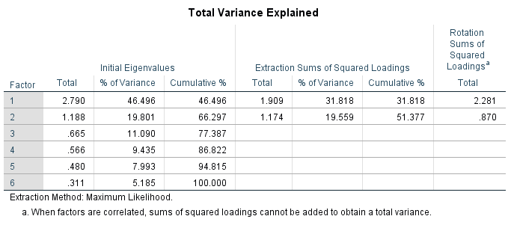

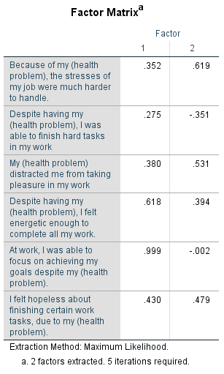

**Appendix C: Exploratory Factor Analysis for SHS**

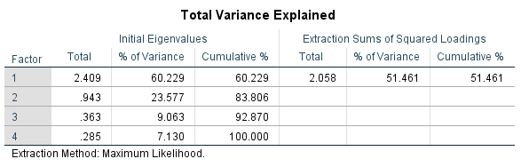

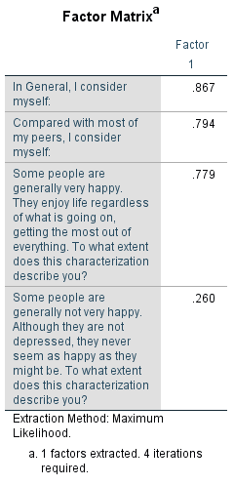

**Appendix D: Exploratory Factor Analysis on JSS**

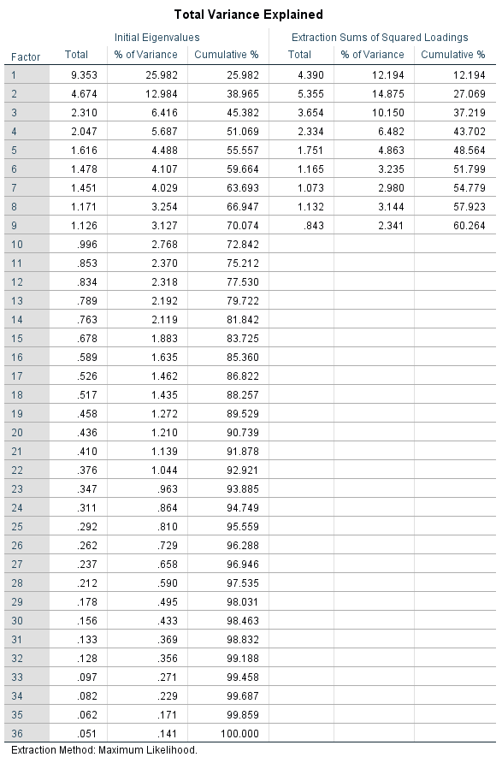

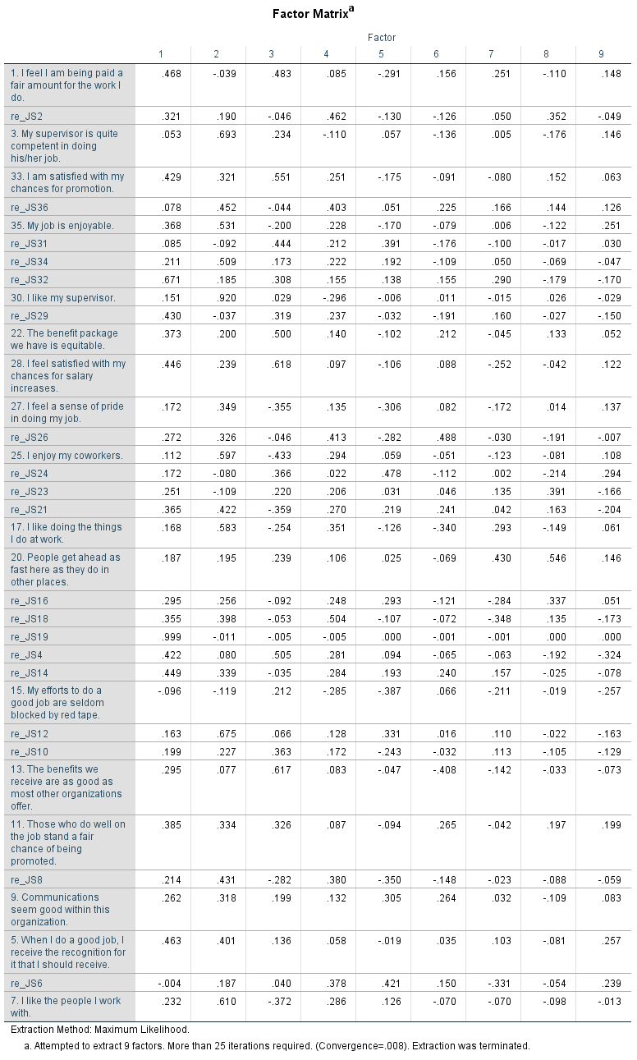

**Appendix E: Test of Normality**

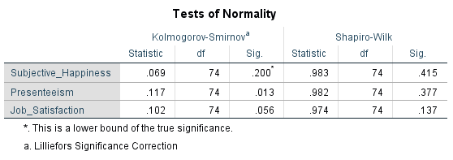

**Appendix F: P-P Plot for Assumption of Linearity**

**Appendix G:** **Scatterplot of residuals for Assumption of Homoscedasticity**

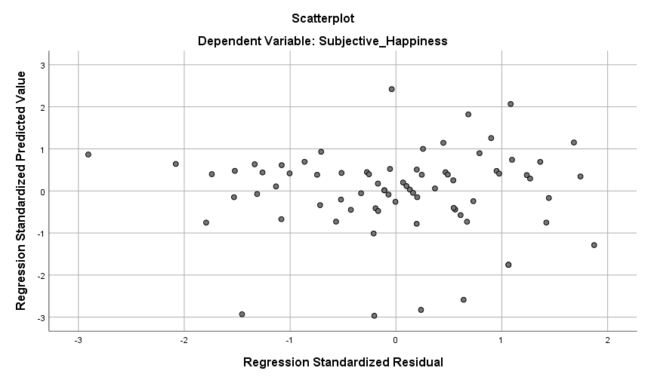

**Appendix H: Assumption of multicollinearity**

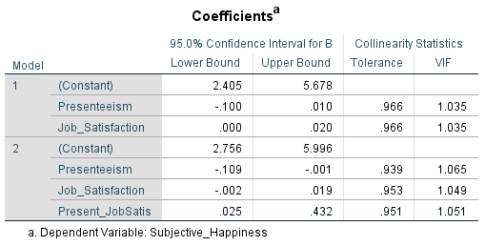

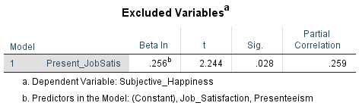

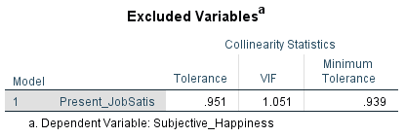

**Appendix I: Simple Linear Regression Analysis for the relationship between Presenteeism and Subjective Happiness**

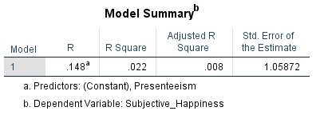

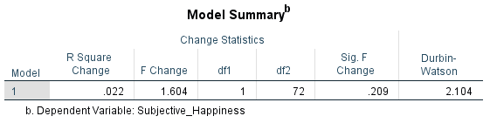

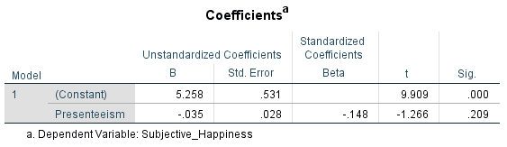

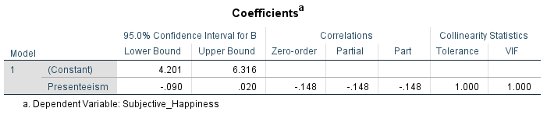

**Appendix J: G*Power Calculation of minimum participants amount.**

